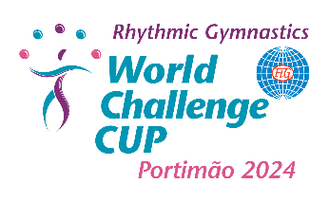

FIG RHYTHMIC GYMNASTICS WORLD CHALLENGE CUP
Individual and Group
Portimão, Portugal
10 - 12 May 2024

GALA REGISTRATION FORM
(Performance on the 12th of May, after the Finals)
Form to be sent to: rgportugal@ginastica.org

FEDERATION OF:

Gymnasts/Group GALA Registration

Individuals | Yes* | No |  | * If Yes | Time for performance | Theme/Title

Groups | Yes* | No |  | * If Yes | Time for performance | Theme/Title

Mixed | Yes* | No |  | * If Yes | Time for performance | Theme/Title
 |  |  |  | * If Yes | Gymnasts: | - .  - .  - .  - .  - .  - .  - .  - .

Date: | Signature/Function
 | Sig.:
 | Function:

