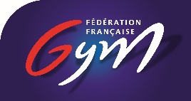

FIG World Challenge Cup Paris
Gym Paris – Internationaux de France
26th-27th September 2026

Form to be sent to: wccparis@ffgym.fr

Organizing Committee / Host Federation
Tom Mollaret (French Federation of Gymnastics)
) +33 1 48 01 24 56 / WCCparis@ffgym.fr

Deadline: 26/08/2026
VISA REQUEST Form

Federation |  | Contact person
Federation |  | Phone
Federation |  | E-mail

LAST NAME  First name | Function | Gender  M/F | Date of birth  dd.mm.yyyy | Citizenship /  passport N° | Passport expiry date | Arrival date | Departure date | City*
* city where the visa application support letter must be sent to

Place and date | Seal of the NF | NF authorised signature
 |  | Signature of the President or Secretary General of the FIG affiliated NF

