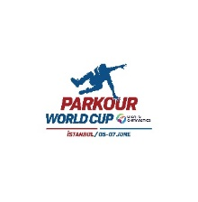
FIG PARKOUR WORLD CUP
Istanbul
05-07 June 2026

Form to be sent to:
Organizing Committee / Host Federation
Turkish Gymnastics Federation
Contact Person: Onur AK Mobile: +90 506 959 43 03
Balgat M. 1416. S. No:14 06520 Cankaya/ANKARA
Telephone: +90 312 310 44 70/126 Fax : +90 312 310 16 23
E-mail : istanbulpk@tcf.gov.tr
Web : www.tcf.gov.tr

Deadline: 03.04.2026
ACCOMMODATION Form

FEDERATION |  | Contact person
FEDERATION |  | Phone
FEDERATION |  | E-mail

Package / Hotel name | Room type  (i.e. single/double/triple/quadruple) | Arr. day | Dept. day | LAST NAME,  First Name | Function | Price per person per night | # of nights | Total
 |  |  |  |  |  | GRAND TOTAL

Special requirements

Place and date | Seal of the NF | NF authorised signature
 |  | Signature of the President or Secretary General of the FIG affiliated NF

